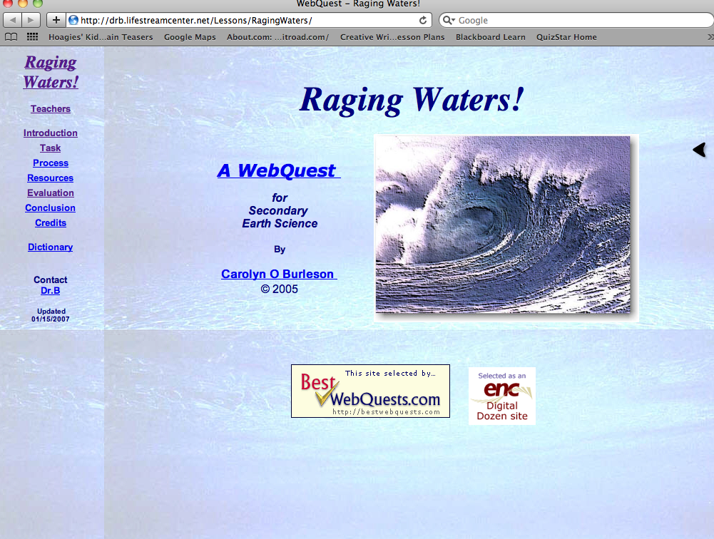

Audience  The intended audience for this webquest would be Earth Science Students in grades 9-12. I think I could adapt the webquest for my students in 6th grade. | Goals  Students will research various natural hazards and determine if natural events that occur in one region of the planet affect other regions in general and California in particular (although I feel I could connect this to Michigan). | Standards  Students are asked to create a cause and effect map which is something my students struggle with. I think this is a great idea and ties in with our standards  E.SE.M.5 Plate Tectonics- The lithospheric plates of the Earth constantly move, resulting in major geological events, such as earthquakes, volcanic eruptions, and mountain building.  E.SE.06.52 Demonstrate how major geological events (earthquakes, volcanic eruptions, mountain building) result from these plate motions. | Pedigogical Usage  I really loved how the author thought about students need for prior knowledge by suggesting the use of a video before webquest.  The author also included a planning sheet, so students would think about the information before hand and consider what questions they had and what they need to know.  Author included rubrics for student review  Uses animated map to show how an earthquake has a ripple effect causing tsunamis. | Opinions/Suggestion  I like how the author included a video that would help students better understand the subject matter. It seems the creator gave a lot of thought to the students different learning styles.  Lots of inquiry and planning.  I might have asked students to input information in a ppt, prezi, somehow they could share information rather than just giving a brief rundown to the class.
 | . | K-7 Standard S.IP: Develop an understanding that scientific inquiry and reasoning involves observing, questioning, investigating, recording, and developing solutions to problems.  S.IP.M.1 Inquiry involves generating questions, conducting investigations, and developing solutions to problems through reasoning and observation.  K-7 Standard S.IA: Develop an understanding that scientific inquiry and investigations require analysis and communication of findings, using appropriate technology.  S.IA.M.1 Inquiry includes an analysis and presentation of findings that lead to future questions, research, and investigations | very easy to read and follow. Students will find this very well explained.  Includes a process guide explaining to students how to manage their time  Identifies what tasks should be done as a group and what should be done independently  Provides students with electronic note cards to keep track of resources  Gives link to next webquest that connects well to the topic  Scaffolding is obvious

Webquest Designer: Carolyn O Burleson

Webquest Review

